DIRECTIONS FOR THE REGISTRATION SERVICE
DISTRICT OF ABERDEEN

In accordance with sections 14(1A)(b) and 23(1A)(b) of the Registration of Births, Deaths and Marriages (Scotland) Act 1965 (as amended by the Coronavirus (Recovery and Reform) (Scotland) Act 2022), and with the approval of the Registrar General, the District Registrar for the registration district of Aberdeen

directs as follows, with effect from 24 September 2022.

In this district, the permitted manner(s) of giving the prescribed information to the registrar during a remote registration of a BIRTH is by telephone

In this district, the permitted manner(s) of giving the prescribed information to the registrar during a remote registration of a STILL-BIRTH is by telephone

In this district, the permitted manner(s) of giving the prescribed information to the registrar during a remote registration of a DEATH is by telephone,

Signed 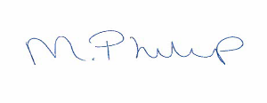 District Registrar

Dated 4th September 2022

